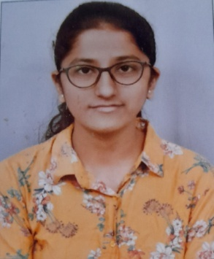
Manisha M Hatalageri
Mobile No: +91-9482467617
Email ID: manishahatalageri@gmail.com

CAREER OBJECTIVE
To get a job in good and creative environment where I can enrich and utilize my skills and knowledge for the growth of the company.

ACADEMICS
Course | Name of the institute | Board/University | Year of passing | Percentage/CGPA
B.E | KLE Technological University, Hubballi | KLE Technological University, Hubballi | Pursuing | 8.46(CGPA till 6th semester)
P.U.C | Vidya. P. Hanchinmani PU Science College, Dharwad | Department of Pre University, Govt. of Karnataka | 2019 | 80%
S.S.L.C | Mayur English medium School, Gokak | Karnataka Board | 2017 | 94.40%

PERSONAL DETAILS
Date of birth: 5th January, 2001
Father’s name: Mallappa Hatalageri
Mother’s name: Jayashree Hatalageri
Permanent address: Drivers’ colony, Gandhinagar, Dharwad
Interests: Drawing, painting, listening to music
Languages known: English, Kannada and Hindi
Skills in programming languages: C language
PROJECTS
Mini project:
- Conducted a survey on the proposed layout.
- Designed Sewage Treatment Plant.
Minor project:
- Proposed a plan for commercial building in AutoCAD software.
- Designed structural members(slabs, beams, columns) and calculated overall load using SAP software.
- Analysed Earned Value Analysis using Primavera software
CERTIFICATIONS
- Feb 2022 Coursera(Work Smarter with Microsoft Excel)
- May 2020 Coursera(Autodesk Certified Professional: AutoCAD for Design and Drafting Exam Prep)

